CARING FOR KIDS
"Quilts, Coins and Prayers for Children"

What then should we do? Whoever has two coats must share with anyone who has none; and whoever has food must do like wise. Luke 3:10-11

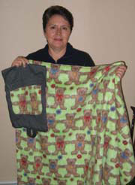
Description
Caring for Kids is a project that will assist our companions, the Evangelical Lutheran Church in Malawi (ELCM), in caring for the increasing number of orphans in Malawi. In Caring for Kids, prayers will be a focal point of the project. People in the NW Synod of Wisconsin will make a simple, child-sized quilt and a tote bag to carry it in.

"Coins" collected will be used to cover shipping costs of the blanket/bag to Malawi (when not hand carried by travelers), to purchase in Malawi personal care items such as tooth brushes/paste, combs, etc. as deemed appropriate by the ELCM, and to cover any shipping tax or surcharge that might be incurred. By purchasing the personal care items in Malawi, it will assure that all items are the same while helping the economy of Malawi and keeping the weight of the quilt/totes down.
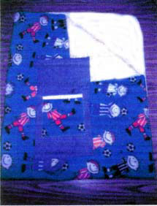
Resources-People
In the NW Synod of Wisconsin, the project leader (Kathy Wohlers) will implement and maintain Caring for Kids. The project leader will also coordinate and arrange for shipping of the quilt bags (designated drop off points will be established, or provide instructions to congregations desiring to ship them on their own.) The project leader will be available to make presentations to interested groups. In Malawi, Diakonia Services will distribute the quilt bags during their regular visits to the feeding centers.

Resources-Financial
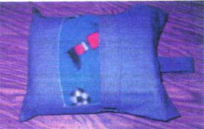
Each person or group sewing a quilt and tote bag will be responsible for purchasing the material or finding funding from others who perhaps may not sew but would like to support the project in this manner. A suggested dollar amount is requested for each bag to cover the cost of shipping and personal care items.

"Coins" collected for the personal care items will be sent to the synod office where it will be wired directly to the ELCM. Until shipping costs and dollar amounts needed for personal care items are determined a suggested amount is $5 to $10 for each quilt/tote bag. Decorated cans or boxes could be made available in individual congregations for anyone wishing to make donations to Caring for Kids.

Suggested prayer before beginning:
Loving God, Father of all, we are called to be the hands and feet of Jesus. Bless the work of our hands and hearts as we help to care for the children of Malawi. Grant that we may be filled with compassion, increasing our understanding of our companions through our labor of love, as our faith continues to grow. For as it has been told to us - "whoever has two coats must share with anyone who has none. And whoever has food must do likewise." As the children hunger, may their bodies be fed. May these quilts be a symbol of your comforting love. Embrace them in the warmth of your love. In the name of Your Son, our Lord and Savior, Jesus Christ. Amen.

Suggested prayer to include tote pocket:
When I lie down. I go to sleep in peace; you alone, 0 Lord, keep me perfectly safe. Amen. Psalm 4:8

This would be a wonderful opportunity to involve the Sunday School children of your congregation by encouraging them to write simple prayers to be included in the tote pockets.

A photo of those who have made the quilt/tote could also be included in the pocket of each tote bag.
