PROJECT: MISSION MART

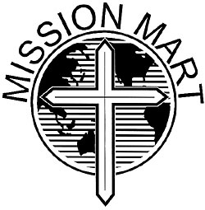
As in most churches, at First Lutheran Church of New Richmond, Wisconsin, there were several mission projects for sale scattered around the church. Because the rooms had changed the use pattern, a new idea was needed.

There was a room adjacent to the overflow area that at present was not in use except for storage. The room and the closet were emptied. Two Mission Committee members repainted the walls to a fresh color. The library shelves were also brought in, books were sorted and arranged. Long tables were set along the walls, each one for one of the mission projects. The Women of the Church sell boxed greeting cards for funds for mission projects. These were set out and arranged for easy viewing. Another table held the Equal Exchange Coffee mission project items. A small clothes rack hold doll dresses sewn by the women of Nicaragua. Each of these dresses is individually wrapped. The closet's new shelves hold extra inventory. The Mission Mart has the following for sale:

Coffee/tea Cards for all occasions Vanilla
Doll dresses Hot chocolate Ornaments
Anniversary Church Books

The Mission Mart has a special sign (symbol above) above the door. The original design was created by Alice Michels. It was laser engraved on an oval wooden base. A separate sign was engraved for the library, which hangs next to the door. If you want a similar sign made, contact Express Laser Engraving, 1998 Highway 65, New Richmond, WI 54701 or phone 715-246-7669. www.expressslaserengraving.com

A church member constructed a wooden box with three slots, one for each mission, fastened to the wall, making it easy for customers to pay for their purchases without an attendant available.

Submitted by the Mission Committee, First Lutheran Church, New Richmond, WI 54017

