Round-lobed Hepatica Anemone Americana
Sharp-lobed Hepatica Anemone acutiloba

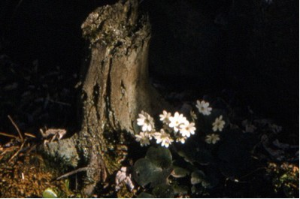
Round-lobed Hepatica Anemone Americana Flowers

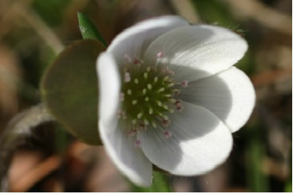

Hepatica Flower

“ … for now the winter is past, the rain is over and gone, The flowers appear on the earth; the time of singing has come, Song of Solomon 2:11-12a (NRSV)

Joy in Finding and Sharing

Winter was past and flowers were appearing on the earth. Our grandmother rejoiced greatly when spring arrived. Each year she searched for the first flowers that would appear in the woods and garden. One of the first flowers in the woods was the Hepatica. Our grandmother called these flowers Mai Blumen or Mayflowers. In her diary we found records of when she first saw them or picked them. Not every year was the same. In 1907 she picked the first ones on April 22nd. In 1910 she found the first ones on March 25th and by April 14th many were blooming. In 1913 a few were blooming on April 17th. In 1925 they had already finishing their blooming by April 26th but in 1928 she picked the first ones on April 30th. There was still snow in some places in the woods. Her diary continued with records of finding and picking these flowers in later years. In some years we found the first flowers around May 1st. That was the traditional May Basket Day and also our father’s birthday. Then we really felt they deserved the name of Mayflower.
In 1931 Grandma and other women served lunch at the church women’s group meeting and they decorated the tables with many wildflowers and Narcissus. Like the writer of the Song of Solomon she rejoiced that spring had arrived. She and others shared their joy at church.
What signs of spring give each of us joy? How can we share our joy with others in church or elsewhere?

Dear Lord,
Help us to find joy in the signs of new life around us. Help us to share our joy of your created world with others. In your name we pray, Amen.

Things to Think About and Do
• Find a Hepatica plant to observe throughout the seasons. Photograph or draw what you see. Write about the pictures.

Hepatica
Purple sepals pale and prim,
Joined around a tiny rim.
Stately stamens standing tall,
Pollen grains on anthers small,
Pistils pointing to the sky
Awaiting insects that come by.
Hepatica is a sign of spring,
And all the joy that it can bring!

Loretta Kuse

• Note where the plants grow well. Read about the kinds of habitats in which each kind of Hepatica will grow.
• Examine a flower with a magnifying glass or hand lens. Count the pistils and stamens in a flower.
• Note the colors of the sepals on the Hepaticas that grow in your area.
• Look at the space between the sepals and the sepal-like bracts on the flower stem.
• Watch to see which insects come to the Hepatica flowers.
• Use the Internet to learn more about the “Doctrine of Signatures” as you read about it in the information section.

