MALAWI HUNGER APPEAL  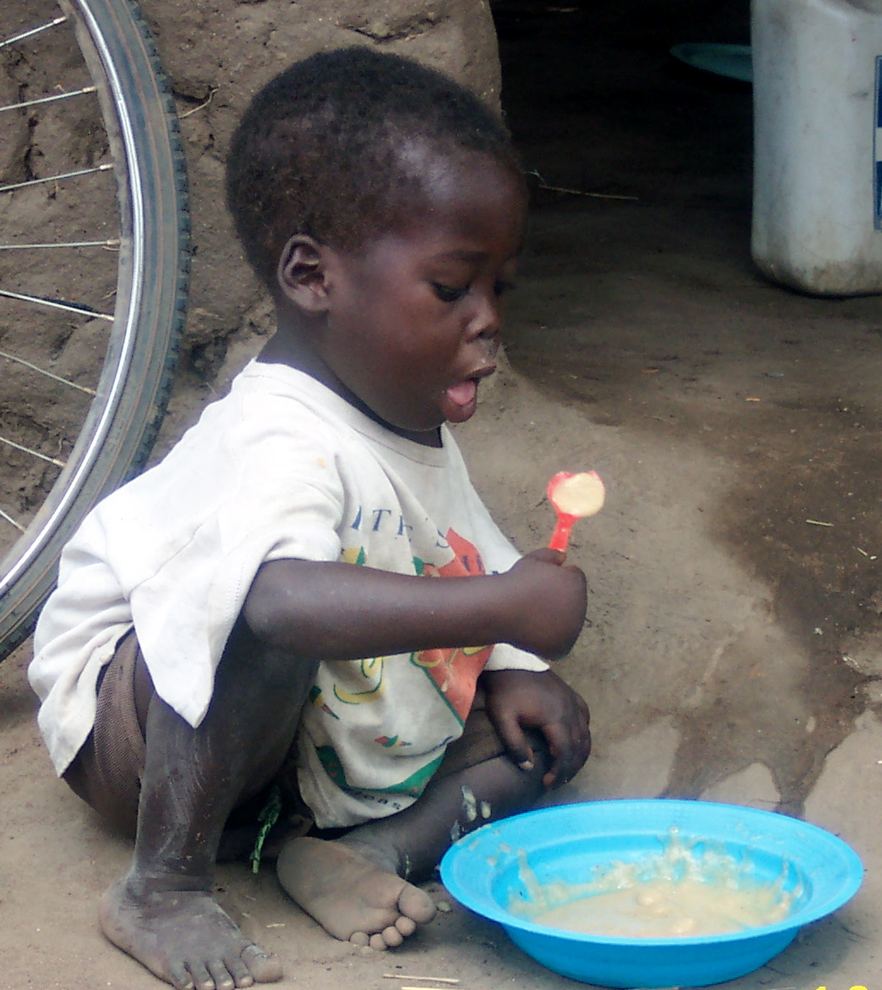  For I was hungry and you gave me food, I was thirsty and you gave me something to drink… Matthew 25:35 | MALAWI HUNGER APPEAL  For I was hungry and you gave me food, I was thirsty and you gave me something to drink… Matthew 25:35 | MALAWI HUNGER APPEAL  For I was hungry and you gave me food, I was thirsty and you gave me something to drink… Matthew 25:35
MALAWI HUNGER APPEAL  For I was hungry and you gave me food, I was thirsty and you gave me something to drink… Matthew 25:35 | MALAWI HUNGER APPEAL  For I was hungry and you gave me food, I was thirsty and you gave me something to drink… Matthew 25:35 | MALAWI HUNGER APPEAL  For I was hungry and you gave me food, I was thirsty and you gave me something to drink… Matthew 25:35

