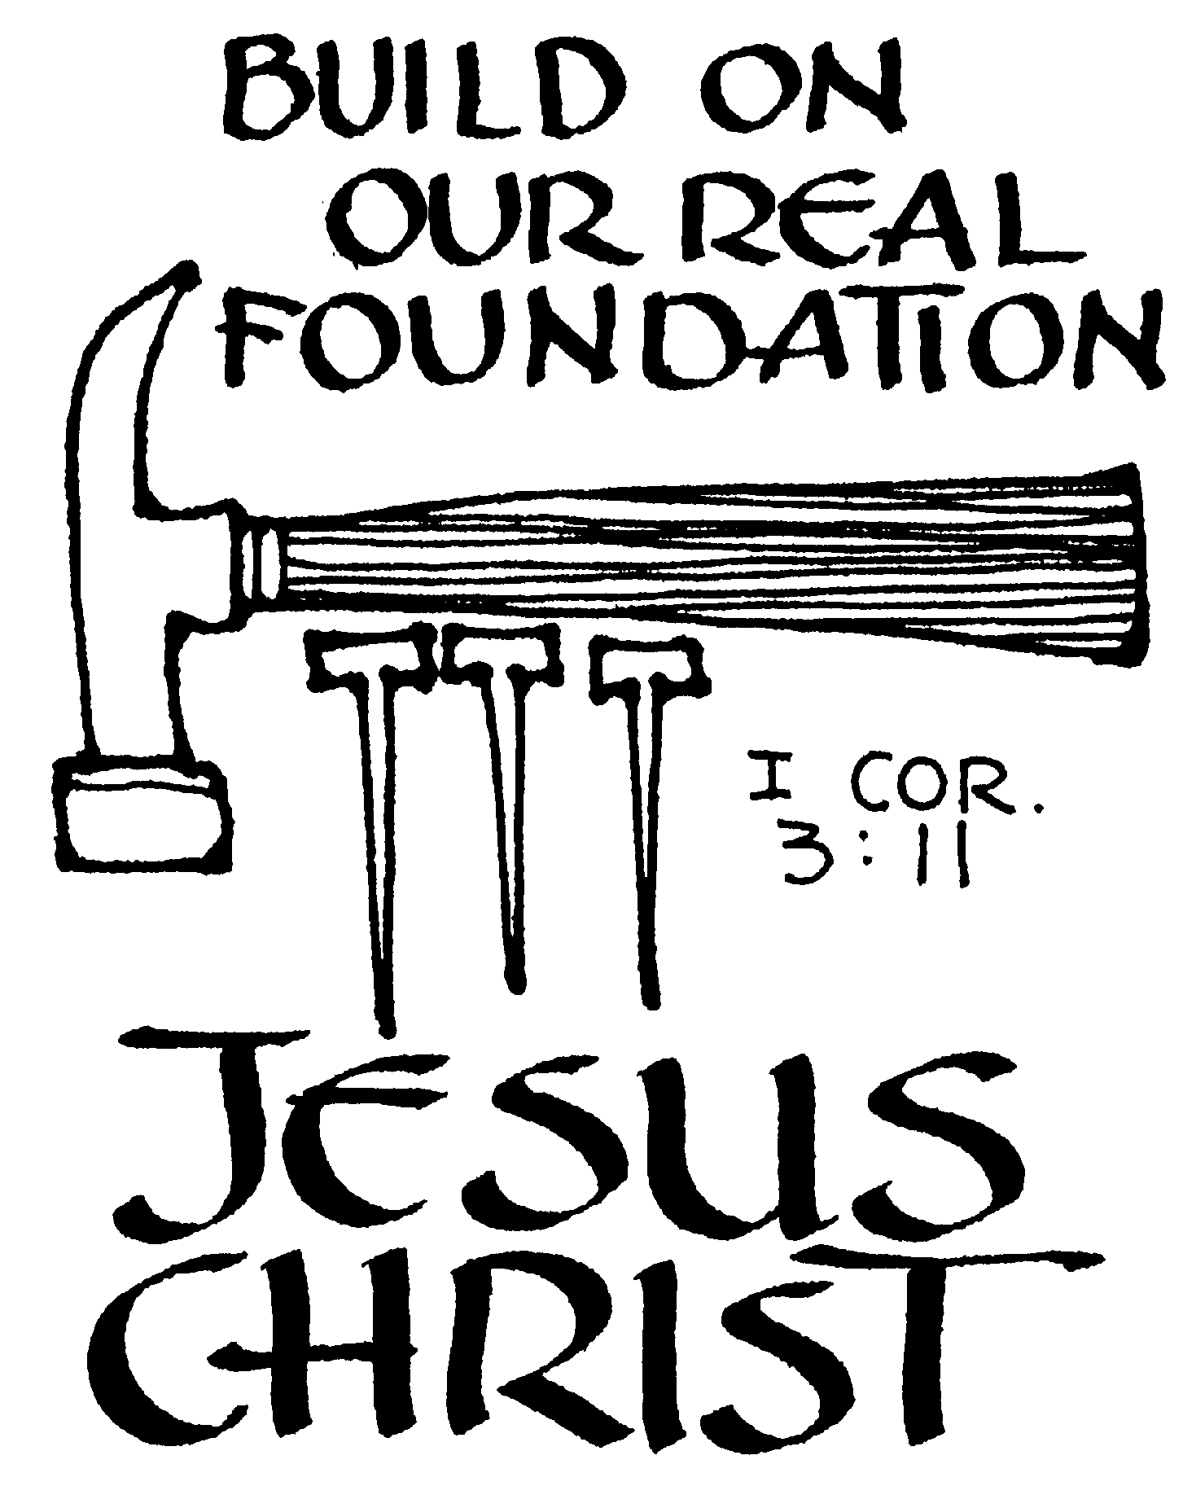

N
A
M
E

Confirmation
Ministry

ST. THOMAS/HOLY SPIRIT LUTHERAN CHURCH
2009-2010

Table of Contents INTRODUCTION

CALENDAR OF EVENTS

COVENANT

LEARNING

FAMILY STUFF

MENTORS

SPIRITUAL FORMATION

SERVANT EVENTS

ADVENT/LENT WORSHIP

WORSHIP NOTES

RETREATS

FAITH STATEMENT

