2009 Senior High Fall Retreat
Cameron Aakre
Sydney Carey
Karla Cordova
Aaron Crume
Mia Dahl
John Deelstra
Anna Dostert
Zack Drechsel
Britta Hulden
Jens Hulden
Bjorn Hunstad
Laura Mills
Jen Sondag
Elise Sperling
Katie Storlie
Kyle Svennungsen
Jacob Swedberg
Kathryn Theige
Larissa Thom
Gabe Wright

Proclaiming peace and praising God for his creation at Inspiration Point since Sept. 25th, 2009!
2009 Senior High Fall Retreat

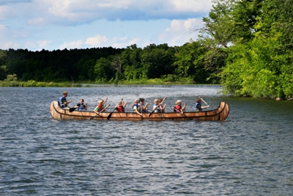

Inspiration Point

Praising God’s beautiful creation through faithful discoveries, peaceful discussion, and much needed relaxation!

September 25-27, 2009

Large Group Hike: Saturday Morning
Thought to consider:
“Peace.
It doesn’t mean to be in a place where there is no noise, trouble, or hard work.
It means to be in the midst of those things and still be calm in your heart.”
~Author Unknown
Opening Prayer:
Holy and Loving Creator,
We thank you for this time to be together in your creation. Help us to slow down and simply be still so we can listen, reflect, and find peace in this place. Thank you for this fellowship and time with good friends. Be with us as we ponder and seek answers, as we sing and dance in worship, and be in the stillness and the silence as we walk through the beauty that surrounds us.
In your Glorious name we pray, AMEN

Hiking and Reflection:
As we walk, we will periodically stop and have time to reflect on topics. As you do so, please be quiet and respectful of others who are still writing or pondering, even as you complete your reflection.

2
Journal Space…

11
3. Fearlessness

Read two or three of these passages:
Psalm 91:9–12; Psalm 139:15–16; Luke 12:4; Romans 8:15-16; Hebrews 2:14-15; Hebrews 13:6.
[Q] Should Christians feel, “I won’t die before my appointed time”? Why or why not?

[Q] If God has appointed a time for each person to die, does this give us safety if we drive recklessly? Why or why not?

[Q] What is the basis for a Christian to approach death with confidence?

[Q] Edward Bloom knew he was made for big things, and he took risks that no one else had the courage to take. How
can you fully embrace the security and confidence God promises?

[Q] Is there a risk you’re afraid to take in your life? How can you step out in faith that God is greater than your fears?

End
[Q] What other themes did you see in Big Fish?
[Q] Did this movie convey messages that troubled you or conflicted with your faith? Explain.
[Q] What in this movie encouraged your faith or helped you see a truth in a new way?

Evening Group Time Reflection Space…

10
• What brings you joy and peace? (List and reflect below)
1.

2.
3.
4.
5.
6.
7.
8.
9.
10.
• What frustrations are keeping you from finding that peace?
1.
2.
3.
4.
5.
6.
3
7.
8.
9.
10.

• What prayer concerns would you like to lift up?
1.
2.
3.
4.
5.
6.
7.
8.
9.
10.

4
[Q] How can our lives become black and white? Give an example. Why is it important to add color?

Read a few of Jesus’ parables from the Gospels (Matthew 18:10–14, Luke 18:1–14, etc.).
[Q] Why did Jesus use stories in so much of his teaching? (Matthew 13:10–17)

[Q] How can storytelling hide something? How can it reveal something?

[Q] What does Jesus’ example tell us about the role of stories in learning to follow him?

2. The Power of Symbolism

Edward Bloom loved to tell the story of the day his son was born.

[Q] Why does Edward enjoy telling this story? What does it mean to him?

[Q] Why does Edward tell this story at Will’s wedding? What does the story reveal about Edward’s feelings for Will?

[Q] What does the big fish represent? What meaning(s) does it hold for Edward?

Read John 10:1–21.
[Q] In this passage, what two main symbols does Jesus use for himself? What do the symbols mean?

[Q] Why do you think people reacted so differently to Jesus’ use of these symbols? (verses 19–21)

[Q] What other symbols does God use in Scripture to express his love for us?

9
Large Group Movie: Big Fish
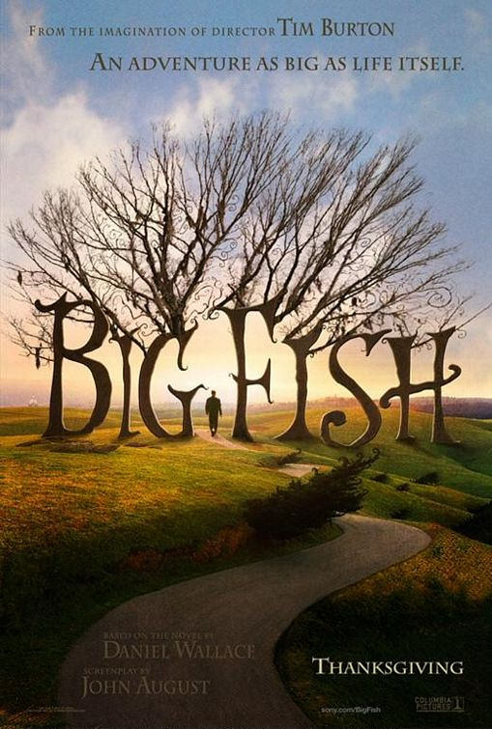

Discussing the Scenes
1. The Power of Story

[Q] Tell about a time when wonder or imagination affected your life.

[Q] Is it important to nurture these qualities, or should we accept that they fade away as we get older?

[Q] In what ways do the media, popular culture, and the pace of life keep you from using your imagination? In what ways do these things encourage you to use your imagination?

[Q] Why do we feel the need to tell stories?

8
Small Group Time
Scripture and Reflections
Share responses and reflections from the hike
~What did you think, hear, or see that gave you a sense of peace in God’s Creation?
Genesis 1 & 2~ The Creation Stories
Look at these two accounts of creation and consider:
~Where do you see peacefulness and gentleness in these two stories?
~In Genesis 2, God is up close and personal: Re-read Genesis 2:7
God is right here. He is close to us, He is with us-always!
John 1: 14~ The Message
“The Word became flesh and blood,
and moved into the neighborhood.
We saw the glory with our own eyes.
The one-of-a-kind glory,
Like Father, like Son,
Generous inside and out,
True from start to finish”

~What does it mean to you to know that God is here-at school, Trinity, home, wherever-in our own neighborhood?
~God is so eager for relationship with us!

5
Matthew 11:28-30
God created this world and filled it with beauty, serenity, and peace, yet we often find ourselves consumed with stress and exhausted from all that we do. He wants to give us time to rest, time to reflect, time to simply be…
~How do you find peace, rest, and stillness in the midst of your busy lives?
~What do you do to rejuvenate yourself when things in life get crazy?

Morning Group Time Reflection Space…

6
Journal Space:

7

