Walking Wet:

Using Facebook to Bridge
the Confirmation Gap

by

A Final Project

Presented to Professor Hess

Luther Seminary

As a Requirement in
Course EL 3517

St. Paul, Minnesota

2011

The Need
One of the concerns of the leadership at Zion Lutheran Church in Muscatine, Iowa, as it is in many other Lutheran churches across the U.S., is the disengagement of our youth following their confirmations. Currently, our program begins in the 7th grade m continues through 8th grade, and culminates early in the 9th grade year with Affirmation of Baptism on or near Reformation Sunday. The 7th and 8th grade years alternate between study of the Old and New Testaments, so the students get both testaments in some order over the two course of the two years. It is a traditional program consisting of discussion, written work, some videos, and lots of memorization of the catechism. But the 9th grade year is different.
The 9th graders separate from the younger students to work with the pastor instead of the lay associate and her two lay volunteers for the roughly two and a months before they are confirmed. The focus is heavily on what it means to be a Lutheran Christian, what it means to be an adult in the church, and practicing for the actual event. But once they are done, very few of the students stay involved. They are disinterested and feel disconnected as they flutter between childhood and adulthood. They seem to view confirmation as an end rather than a beginning, as a graduation from instead of a matriculation into.
Our new pastor has been exploring ways to build stronger connections between the children. The lay associate asked me about creating a way to help the confirmands move from childhood status to adult status and encourage them to remain involved. After our discussions in class about media, I thought this could be the way to reach the kids.
The Idea
Most of the confirmation-age students I work with at church and school are very involved on Facebook. Our schools finally gave up trying to block the students from using it at school because even the teachers are finding ways to incorporate it into the classroom. I decided if the school could do it, why not the church? The kids are already a presence there and I have experience setting up and administering groups. I ran the idea past several of our older high school students and they were willing to admit it might be a good idea (actually a ringing endorsement from teenagers!), so I went forward with the project.
After discussing it with the pastor, we fixed on a basic premise of encouraging the confirmands to think of how they might live out their baptized lives in the months immediately following their confirmation and on into the years that follow as they move into adulthood. Our ultimate goal is to keep the kids involved by starting them out with the group page only for them before confirmation is over and then continuing through their first 9-12 months as new confirmands. At that point we will consider whether to graduate them from the group or just keep adding the newer kids as they come along. Either way, it gives an opportunity for our kids to build community on a page of their own.
The Project
I created a Facebook group called “Walking Wet” for our confirmands. I am currently the administrator, but I have added the pastor (who is quite conversant in social media) and the lay associate (even though she doesn’t have a lot to do with the 9th graders). The three of us are still talking about what the page might look like after this first year and whether an adult will be the administrator or whether we will consider turning the page over to the kids to administer themselves. We will have to see how this first year with it goes.
As you can see by the screen shot of the group page below, we are starting slowly. We still need to find and friend all of the kids from the church, send them invitations, and get things started. I chose to begin by having a contest to name the page. I explained that I had to give it a name to start, but that we could change it. It remains to be seen whether the kids will get on board, but hopefully it will be a beginning.
I have the next few warm-up communications ready to go—asking them each to submit a picture of water (we live on the Mississippi so that won’t be too difficult) and then one of their favorite pair of shoes. Then we’ll choose among these for a new profile pictures. This should take us through the beginning of school in mid-August and give us time to get everyone invited into the group. Then we’ll move into asking open-ended questions such as, “What does it mean to be Lutheran?” and “When you think of yourself 5 years from now, what do you you’ll be doing at church?” I will probably pose the questions myself at first, but encourage the kids to ask their own with an eye toward letting them lead future discussions.
I believe this not only a project for a place. This is very much a work in progress, so we’ll just have to see how it goes!
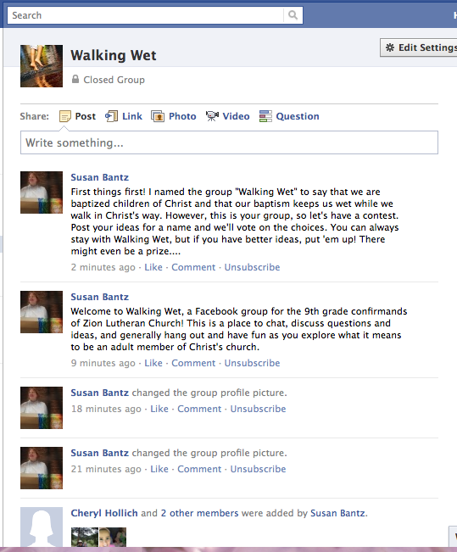
Figure 1: The new Facebook page for “Walking Wet,” the group I created for Zion Lutheran Church’s 9th grade confirmands.

