Louie Giglio: The Heart of Passion

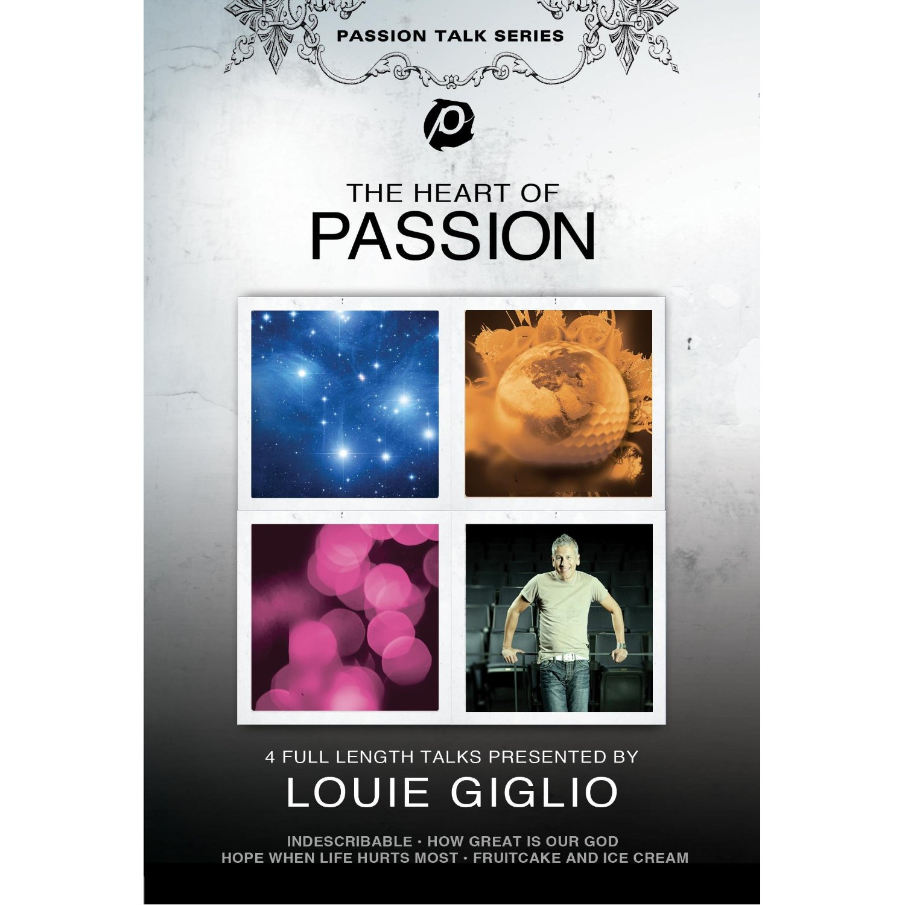

Introduction

The Heart of Passion is a series of talk presented by Louie Giglio. This series consist of 4 full lengths title: Indescribable, How Great is Our God, Hope: When Life Hurts Most, and Fruit Cake and Ice Cream. The Passion Movement have impacted “millions of people around the globe, calling people to live for the glory of God.”

Taken from Amazon website

Indescribable
The heavens are telling the glory of God, and their expanse declares the work of His hands. Indescribable takes us on an image-rich journey through the cosmos, allowing us to peer into God's universe to discover the amazing magnitude of His greatness and grace.

How Great Is Our God
Our life is a miracle, and the Creator of the universe knows each of us by name. He's big enough to breathe out stars, yet intricate enough to fashion together the trillions of cells that make up every facet of who we are. And he cares about each of us & promises to carry us through. He will hold onto you and hold you together, giving strength to those who hope in His unfailing love

Hope: When Life Hurts Most
Life isn't easy. We Experience problems and setbacks every day. But during the hardest parts of life, when the bottom seems to fall out, where do we turn for peace? God offers Himself and His cross as an anchor of hope no matter what we face in life. The hope we find in Him allows us to leverage our darkest moments for His fame.

Fruitcake And Ice Cream
An unlikely collision of friendship & grace is demonstrated in this message that breathes hope for the spiritually searching while providing massive kick-start for those within the church who carry the unrivaled story of God's grace and truth in a darkened world.

Materials:

A copy of Louie Giglio: The Heart of Passion (follow the link)

http://www.amazon.com/Louie-Giglio-The-Heart-Passion/dp/B001R7IH5A/ref=sr_1_1?ie=UTF8&qid=1332142980&sr=8-1

Projector and projector screen
DVD player / Computer that plays DVD
Room big enough for the group

Instruction

Week 1: Watch Indescribable

Week 2: Watch How Great is Our God

Week 3: Watch Hope: When Life Hurts Most

Week 4: Watch Fruitcake and Ice Cream (optional)

Each talk should last around one hour. After the movie, divide the group into small groups. If possible, appoint each small group a group leader (church member) to facilitate the discussion.

Because this most of the kids in the group are non Christians, it would be a good idea to introduce each other. After the introduction, start the discussion by asking the following questions:

- What do you find most interesting about the talk?
- What questions do you have about the presentation?
- What part of the presentation speak to you?

These are generic questions meant to start a conversation with the group. The important thing is to get them to think about more than just themselves, to talk think about the possibility of a God who loves us.

After the group discussion, the group leader will go around and ask the group for prayer request. The group leader will end the night with a prayer.

Repeat this process for 3 weeks.

