PIRATES and the GALILEAN

WRITTEN ESPECIALLY FOR

Older Wiser Lutherans of
Good Shepherd ELCA
D Wright SPSRC
Fresno CA
June, 2007

EPISODE: Crossing to the Other Side

Based on Mark 5:35 & 7 Faith Practices

Notes:
The first boat represents Good Shepherd, the church, and our faithful following of Jesus and growing in our 7 Faith Practices.

Characters:

Captain = Jesus

QM = Quartermaster Simon Peter

First Mate =James

Second Mate = Bartholomew

Crew I

The second boat is the GMS [Grand Mischievous Ship] Jolly Roger. The pirates heard Jesus at Capernaum, but are not yet believers.

Captain Jack Sparrow

QM = Quartermaster Black Sam

First Pirate= Grace O’Malley

Second Pirate= Jean Lafitte

Crew II

Scene l: Afternoon, the day is warm and sunny and a delightful breeze is blowing. Aboard the Jolly Good Shepherd.

Jesus: This has been a good week in Capernaum. Let’s get in the boat

And go to the other side of the Lake.

QM Simon Peter: Yes, Yes, Captain. James, Bartholomew—make ready
to shove off.

James & Bartholomew: Aye, Aye. [To the crew] Untie the ropes, man the jib, and hoist the sail!

Crew I: Aye, Aye. [To each other] After that crowd the last few days in Capernaum, this is going to be a beautiful trip.

Jesus [sits down, yawns and appears to be ready to fall asleep]

Scene2: Later that afternoon, Aboard the GMS Jolly Roger.

[ALL Pirates are heard singing: Yo, ho, ho and a bottle of rum!]

Captain Jack: Looks like a great day for sailing!
[to QM Black Sam] Did you bring the life preservers?

QM Black Sam: Aye, Aye Jack! You know my motto…er…Pirate safety

First!

Captain Jack: Not meaning to be rude Quarter Master, but we have never used the life preservers!

QM Black Sam: Yes Jack, we haven’t. However that Boy Scout Water Safety book that we stole from the kids strictly says you must always have them aboard!

First Pirate Grace: If we ever leave the dock, what does it say about getting lost?

QM Black Sam: I run a tight ship me ‘mateys and we will observe the right protocol!

Crew II: Aye, Aye [to each other] He runs a very tight ship until he’s had too much rum.

Second Pirate: Not much wind today, Black Sam.

QM Black Sam: Don’t worry about the wind. You know my motto…

Crew II: Red sky at morning, sailors take warning?

QM Black Sam: No, no, no. Safety First. Besides, a quiet Sea of Galilee will give us a chance to sneak up on that boat over there. [He points to the Jolly Good Shepherd].

First Pirate Grace: [Shades eyes and peers into the distance] Don’t see a thing. What did you think of that Galilean preaching at Capernaum?

Second Pirate Jean: He caused me to think about my life, he did.

Captain Jack Sparrow: Why he said we was all brothers and sisters! Imagine that—Jews, gentiles, and pirates—his brothers and sisters.

QM Black Sam: Can’t believe that! Why that would mean chasing down these ships—well—we might be thieving’ from our own family!

Crew II: [All laugh, talk to each other] Yeah! Imagine that—our brothers and sisters.

QM Black Sam: We are nearly at the south end of the Lake. It’s always stormy here.

Second Pirate Jean: LOOK! We are close enough to see the people on the other boat! Why it’s that group that was with Jesus, the Galilean.

First Pirate Grace: Black Sam, I’m beginning to feel very sick—the boat is really rocking.

Second Pirate Jean: Black Sam, the wind is really strong!

QM Black Sam: Captain! Captain! What should we do? I’m NOT PREPARED FOR THIS!

Scene 3: The Storm – BOTH CREWS sway from side to side as if boats are rocking.

The Jolly Good Shepherd Crew I begin to panic.

Crew I: Quarter Master Simon Peter, the water is very rough. The boat is rocking, let’s turn back.

QM Simon Peter: Master, Master! Wake up, wake up! We’re about to turn over! The boat is rocking badly.

First Mate James: Master, don’t you care? The water is so rough.

Second Mate Bartholomew: I don’t think we’re going to make it to Gerasa!

Jesus: [Stretches and stands up] BE STILL! BE STILL, WIND AND WAVES.

[Jesus pauses while ALL STOP SWAYING]

Jesus: [To the QM and crew] Don’t you have any faith? I am with you today. God is with you always. You are safe with me and believing IN me!
Crew I [To each other] Amen. He is the Son of God. We are safe with him.

Scene 4: A few minutes later on the GMS Jolly Roger.

Crew II: [to each other] I can’t believe it—he stood up and said “Be still” and the wind died down. And the sea became calm!

First Pirate Grace: His preaching, why he really knows what he’s talking about.

Second Pirate Jean: He caused me to think, he did! And he saved US! I certainly believe he is the Son of God.

QM Black Sam: I’d like to meet him again.

Captain Jack Sparrow: Ahoy! Ahoy there! Jesus! Tell us more about your faith.

THE END

The following 3 pages

Include
Pirate Flag, Sign
And
Sea of Galilee Map

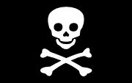
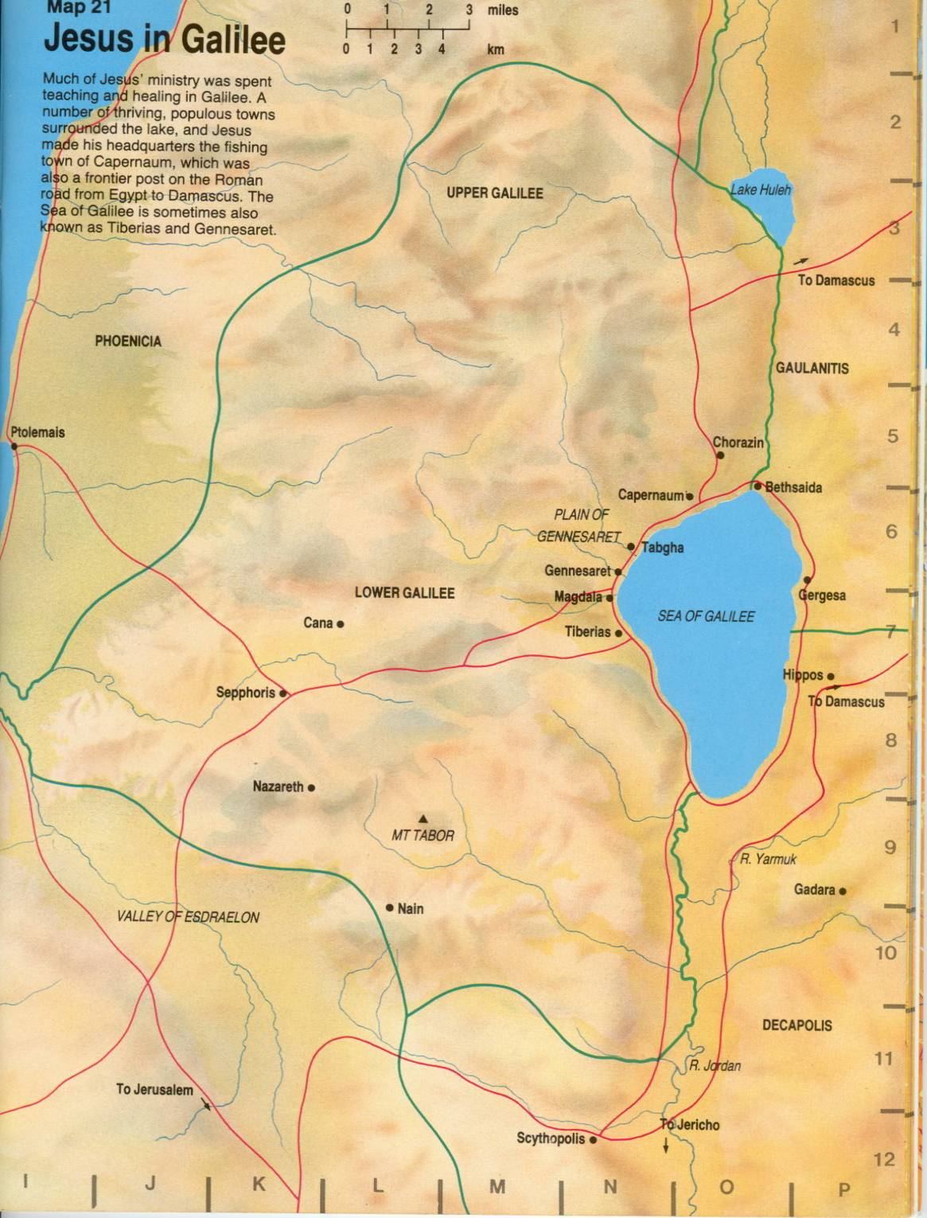

Figure 1 Pirates and the Galilean from A/F Bible Atlas

USS JOLLY GOOD SHEPHERD

ALL YE WHO ENTER HERE BEWARE,

FAITH LURKES!

